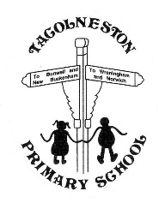
THE TACOLNESTON FLYER
www.tacolneston.norfolk.sch.uk

As each has received a gift, use it to serve one another, as good stewards of God’s varied grace
1 Peter 4:10

Week 16 – 14th January 2022

Our Value for Life this term is Friendship

Kingfisher Class

Chickens!! - We would really like to be able to hatch chickens at some point this term, for this we need to source some fertilised eggs, an incubator and lovely people willing to home the chicks - if anyone has any contacts or able to offer any help with this we would be very grateful.

Thank you B & Q

An enormous Thank you to Melissa at B & Q, Hall Road, Norwich for very kindly donating 30 plastic buckets which Eagles are using in their Music sessions. We look forward to performing with them in the near future. Watch this space!

Eagles Learning Café

The date for the Eagles Learning Café has changed from February to Tuesday, 10th May.

Mr Smith’s Club

Mr Smith’s after school club is now full. There are still spaces in the club he runs before school for those children in KS1. Please make payments directly to Mr Smith.

Costs are: Before school - £2. After school - £3. The bank details are on the consent forms, if you have any queries please see the office.

Dinner Money

We would be grateful if you would settle any outstanding dinner accounts immediately. There are still payments from September which have yet to be paid.

Changes to the self-isolation period for those who test positive for COVID-19

From Monday 17 January, people who are self-isolating with COVID-19 will have the option to reduce their isolation period after 5 full days if they test negative with a lateral flow device (LFD) test on both day 5 and day 6 and they do not have a temperature. For example, if they test negative on the morning of day 5 and the morning of day 6, they can return to their education or childcare setting immediately on day 6.

The first test must be taken no earlier than day 5 of the self-isolation period, and the second must be taken the following day. All test results should be reported to NHS Test and Trace.

If the result of either of their tests is positive, they should continue to self-isolate until they get negative results from two LFD tests on consecutive days or until they have completed 10 full days of self-isolation, whichever is earliest.

Anyone who is unable to take LFD tests or anyone who continues to have a temperature will need to complete the full 10 day period of self-isolation.
Further information on self-isolation for those with COVID-19 is available.

Parking

We have had complaints from neighbours about parents leaving their engines running while waiting for their children.

We would ask that you park safely and considerately while dropping or collecting your children.

Kingfishers’ have been reading Handa’s Surprise this week. Here is their classroom display.

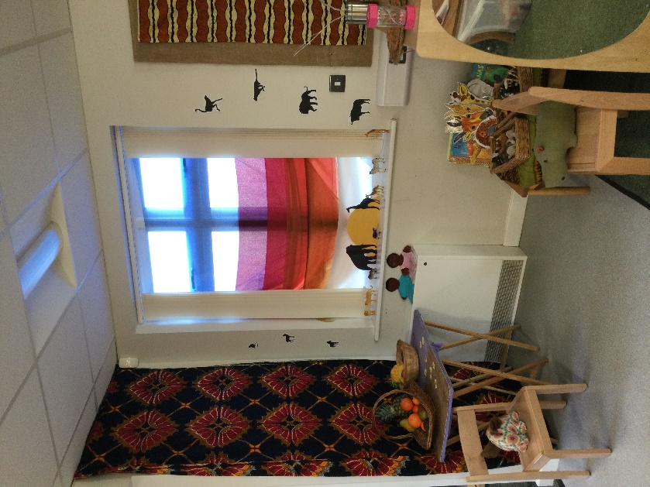

Pupils of the Week

Our awards are given to pupils in recognition of them
demonstrating one of our school values.

Kingfishers Evie - Wisdom

Robins Thea - Perseverance
Triston D - Forgiveness

Eagles Lucas - Perseverance
Scarlett G – Respect

Sparrowhawks Jamie – Perseverance
Noah - Creativity

Merit Badges James, Charlie, Finlay W, Austin

Going for Gold Pippa C (Silver)

Reading Star Rosie P

HOUSE TEAM SCORES – this week

AUTUMN | WINTER | SPRING | SUMMER
40 | 46 | 34 | 41

TOTAL HOUSE TEAM SCORES

AUTUMN | WINTER | SPRING | SUMMER
611 | 577 | 657 | 600

If you are new to the school, welcome! Please do join our Facebook group https://www.facebook.com/groups/TacolnestonFOTS/or email us at friendsoftacolneston@gmail.com to keep abreast of important news and upcoming events.

